**EE PROJECT**

BY:

Aatmaj Mhatre (16010121110)

Ujjawal Patel (16010121137)

Shubraja Lalith (16010121100)

Om Kelkar (16010421045)

**Title**

Training therapy for disabled persons/ toddlers.

**Field of invention**

We have prepared the product with the following objectives in mind:

* Developing a product that improves motor skills and hand eye coordination among disabled persons and toddlers.
* Finished product should be battery operated to increase portability.
* Product should be compact, around 30cm wide and 40cm long

Our potential buyers are schools, creches and therapy centres, where teachers and doctors can use the product for therapy/ motor skills improvement of students and disabled persons.

Background of invention/Literature Survey

A research was conducted on 78 children in the age group 8-10 using a

similar mechanism.

(https://www.sciencedirect.com/science/article/pii/S0167945716302974)

Random numbers appeared on the screen and a keypad was used to enter

the number. This exercise improved the manual dexterity scores of the

children.

A very similar study on keyboard positions was conducted which proved

increase in eye-hand coordination skills.

(https://booksc.org/ireader/24159130)

Another study applies a similar principle of mole hitting for increasing the

eye-hand coordination. It employs three methods for doing so. Mole hitting

for random operations, balloon catching game for vertical movement, and

the fish catching game for horizontal transfer. However, this setup is very

sophisticated, bulky, and costly.

(https://www.jstage.jst.go.jp/article/jrobomech/26/6/26_704/_pdf/-char/

ja)

A recent study maps video games to development of eye hand coordination.

(https://www.sciencedirect.com/science/article/abs/pii/S003960602030819

9)

Object of invention

While preparing the product, we gave a lot of thought on keeping the product light, compact, portable and battery operated. We initially thought of making an app-based game but instead decided to go with a hands-on device as many parents try to reduce their child’s phone screen time as much as possible.

Description of Drawing

* The design for the chasis is inspired by a typewriter design, to give the feeling of a keyboard and output together. Also, the placing of the keys in the typewriter match the placing of our switches.
* On the box’s top surface, the LEDs will be placed, and at position (2), the switches/keys will be placed. The hole provided at position (4) is for the charging port. It is kept in the side to have uninterrupted use while charging.
* In the interior part, we have kept enough room for the housing of the Arduino board, battery, and the connecting wires. To secure the wiring and other internal components there will be clips on the internal wall of the box.

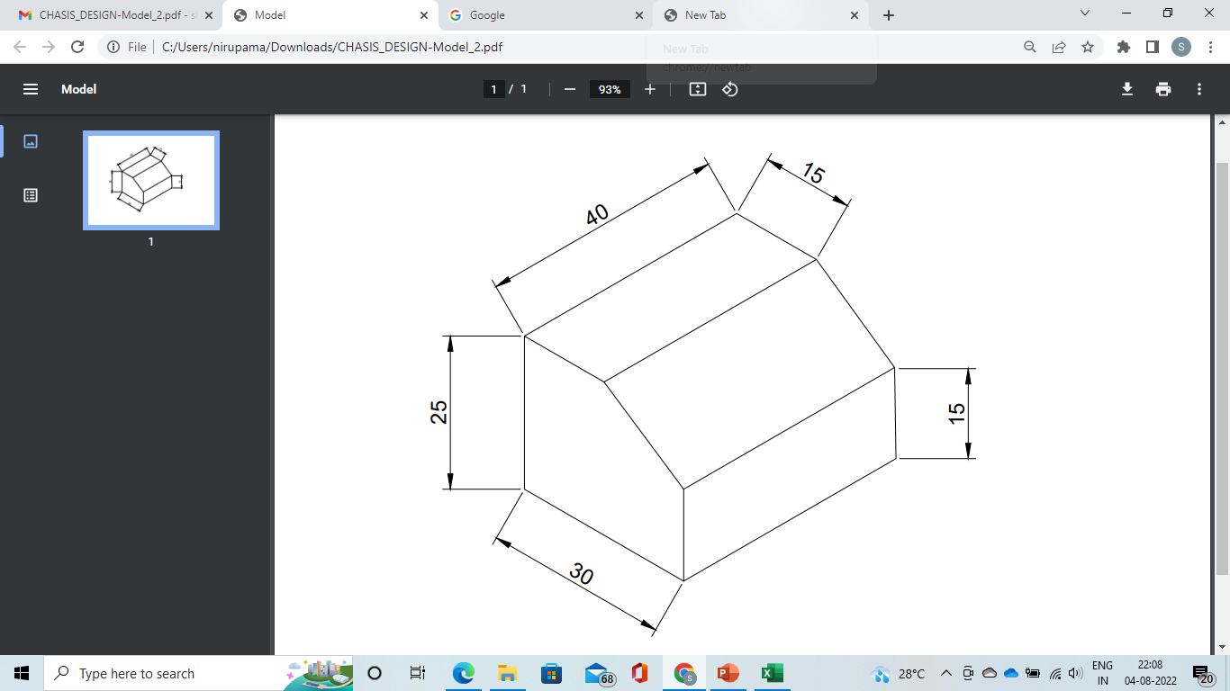

* 1 – LED
* 2 – Switches/Buttons
* 3 – Position of Arduino and Battery Pack
* 4 – Charging port for battery

Timeline

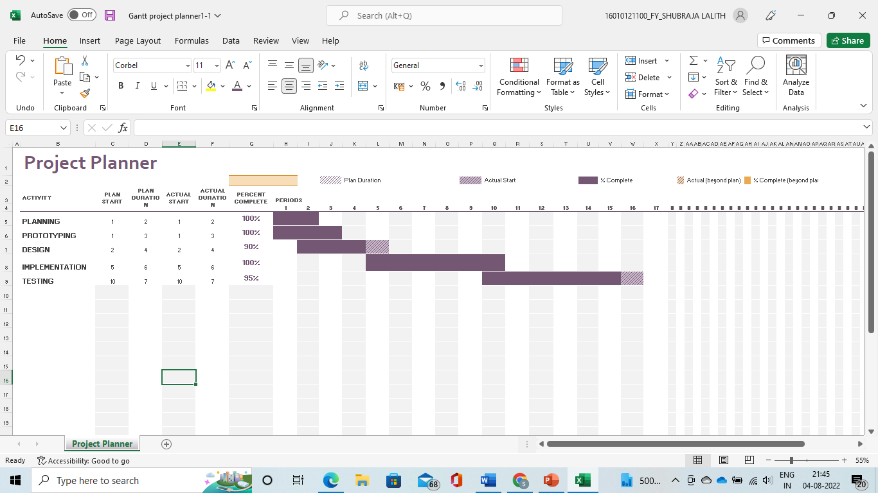

Summary of invention

Our product has a game-like box setup wherein random colours are generated (using the LEDs) and the user presses the button which corresponds to the colour displayed. The final score is displayed on an app, which indicated how many colours were guessed correctly and the time taken for all the guesses.

Circuit Diagram, TinkerCad Model and Components Used

The product

